ECO394D Probability and Statistics Homework 1

Sibo Ding

Summer 2023

library(dplyr)

##   
## Attaching package: 'dplyr'

## The following objects are masked from 'package:stats':  
##   
## filter, lag

## The following objects are masked from 'package:base':  
##   
## intersect, setdiff, setequal, union

library(ggplot2)

## Problem 1

### Part A

## david.bowie  
## daft.punk 0 1  
## 0 0.925 0.912  
## 1 0.075 0.088

### Part B

xtabs(~ johnny.cash + pink.floyd, data = plays) |>  
 prop.table(margin = 2)

## pink.floyd  
## johnny.cash 0 1  
## 0 0.94503203 0.89517154  
## 1 0.05496797 0.10482846

$P\left(johnny.cash=1|pink.floyd=1\right)=0.10$ $P\left(johnny.cash=1|pink.floyd=0\right)=0.05$ These numbers are pretty close, which means different results of Pink Floyd do not change the results of Johnny Cash very much. Therefore, Pink Floyd and Johnny Cash are independent.

## Problem 2

### Part A

sb <- read.csv("superbowl.csv")  
  
xtabs(~ danger, data = sb) |> prop.table()

## danger  
## FALSE TRUE   
## 0.6963563 0.3036437

$P\left(danger=TRUE\right)=0.30$

xtabs(~ danger + funny, data = sb) |>  
 prop.table(margin = 2) |>  
 round(2)

## funny  
## danger FALSE TRUE  
## FALSE 0.88 0.61  
## TRUE 0.12 0.39

$P\left(danger=TRUE|funny=TRUE\right)=0.39$ $P\left(danger=TRUE|funny=FALSE\right)=0.12$ Ads using humor are more likely to feature danger.

### Part B

xtabs(~ animals, data = sb) |> prop.table()

## animals  
## FALSE TRUE   
## 0.6275304 0.3724696

$P\left(animals=TRUE\right)=0.37$

xtabs(~ animals + use_sex, data = sb) |>  
 prop.table(margin = 2) |>  
 round(2)

## use_sex  
## animals FALSE TRUE  
## FALSE 0.63 0.62  
## TRUE 0.37 0.38

$P\left(animals=TRUE|use_sex=TRUE\right)=0.38$ $P\left(animals=TRUE|use_sex=FALSE\right)=0.37$ use_sex and animals look nearly independent.

### Part C

xtabs(~ celebrity, data = sb) |> prop.table()

## celebrity  
## FALSE TRUE   
## 0.7125506 0.2874494

$P\left(celebrity=TRUE\right)=0.29$

xtabs(~ celebrity + patriotic, data = sb) |>  
 prop.table(margin = 2) |>  
 round(2)

## patriotic  
## celebrity FALSE TRUE  
## FALSE 0.71 0.71  
## TRUE 0.29 0.29

$P\left(celebrity=TRUE|patriotic=TRUE\right)=0.29$ $P\left(celebrity=TRUE|patriotic=FALSE\right)=0.29$ celebrity and patriotic look nearly independent.

## Problem 3

### Part A

profs <- read.csv("profs.csv")  
  
profs |> ggplot(aes(eval)) +  
 geom_histogram() +  
 xlab("Course evaluation score") +  
 ylab("Count")

## `stat_bin()` using `bins = 30`. Pick better value with `binwidth`.

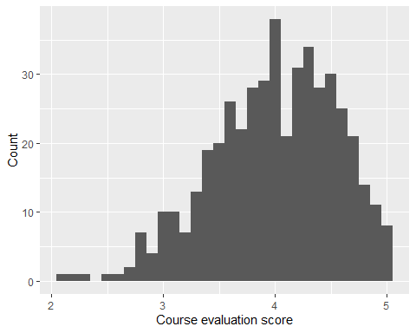

x-axis shows different course evaluation scores. y-axis shows the number of occurrences of the corresponding score.

### Part B

profs |> ggplot(aes(native, eval)) +  
 geom_boxplot() +  
 xlab("Native English speaker or not") +  
 ylab("Course evaluation score")

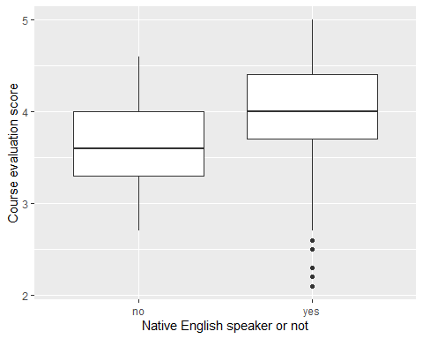

Summary distribution of course evaluation scores based on professors’ native languages.

### Part C

profs |> ggplot(aes(eval)) +  
 geom_histogram() +  
 facet_wrap(~ gender, nrow = 2) +  
 xlab("Course evaluation score") +  
 ylab("Count")

## `stat_bin()` using `bins = 30`. Pick better value with `binwidth`.

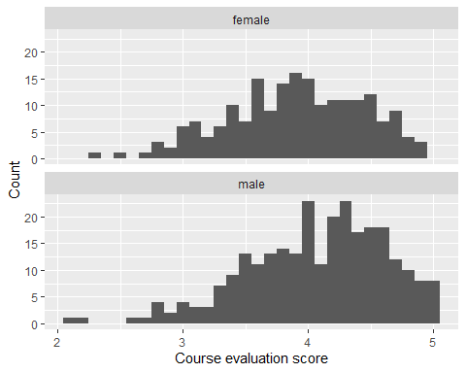

x-axis shows different course evaluation scores. y-axis shows the number of occurrences of the corresponding score, for either male or female.

### Part D

profs |> ggplot(aes(beauty, eval)) +  
 geom_point() +  
 geom_smooth(method = "lm", se = FALSE) +  
 xlab("Physical attractiveness") +  
 ylab("Course evaluation score")

## `geom_smooth()` using formula = 'y ~ x'

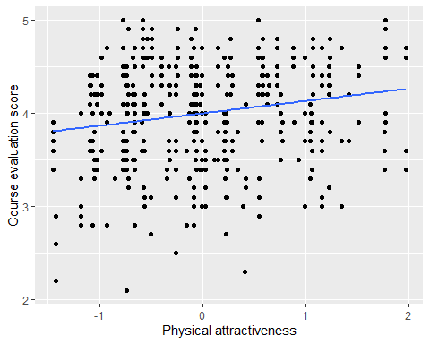

Each point corresponds to its coordinate.

## Problem 4

sat <- read.csv("utsat.csv")  
  
# Define a function that returns a data frame of summaries  
fn_summary <- function(x){  
 data.frame(mean = mean(x),  
 sd = sd(x),  
 IQR = IQR(x),  
 percentile_05 = quantile(x, 0.05),  
 percentile_25 = quantile(x, 0.25),  
 median = median(x),  
 percentile_75 = quantile(x, 0.75),  
 percentile_95 = quantile(x, 0.95)) |>  
 round(2)  
}  
  
# Create 3 data frames of summaries  
a <- sat |> summarize(fn_summary(SAT.V))  
b <- sat |> summarize(fn_summary(SAT.Q))  
c <- sat |> summarize(fn_summary(GPA))  
  
# Concatenate 3 data frames and output as a table  
a |> rbind(b) |> rbind(c) |> knitr::kable()

| mean | sd | IQR | percentile_05 | percentile_25 | median | percentile_75 | percentile_95 |
| --- | --- | --- | --- | --- | --- | --- | --- |
| 595.05 | 83.77 | 110.00 | 460.00 | 540.00 | 590.00 | 650.00 | 730.00 |
| 619.98 | 83.08 | 120.00 | 480.00 | 560.00 | 620.00 | 680.00 | 760.00 |
| 3.21 | 0.48 | 0.72 | 2.36 | 2.87 | 3.25 | 3.59 | 3.92 |

Key summary statistics for SAT Verbal, SAT Quantitative, and GPA.

## Problem 5

### Plot A

bs <- read.csv("bikeshare.csv")  
  
bs |> group_by(hr) |>  
 summarize(mean_total = mean(total)) |>  
 ggplot(aes(hr, mean_total)) +  
 geom_line() +  
 xlab("Hours of a day") +  
 ylab("Average hourly bike rentals")

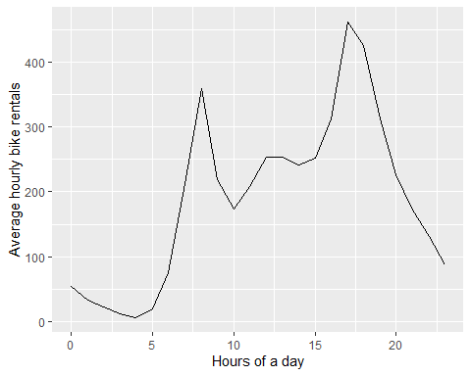

The line plot shows the time-series (hourly) change of bike rentals of a day (24 hours).  
Lesson: There are 2 peaks at 8:00 and 17:00.

### Plot B

bs |> group_by(workingday, hr) |>  
 summarize(mean_total = mean(total)) |>  
 ggplot(aes(hr, mean_total)) +  
 geom_line() +  
 facet_wrap(~ workingday, nrow = 2) +  
 xlab("Hours of a day") +  
 ylab("Average hourly bike rentals")

## `summarise()` has grouped output by 'workingday'. You can override using the  
## `.groups` argument.

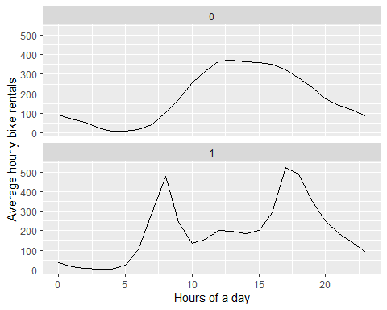

The line plots show the time-series (hourly) change of bike rentals of a day (24 hours). There are 2 groups, “1” represents working day, “0” otherwise.  
Lesson: On working days, there are 2 peaks at 8:00 and 17:00; on non-working days, the change is flatter, 12:00 - 16:00 is higher, 3:00 - 6:00 is lower.

### Plot C

bs |> filter(hr == 9) |>  
 group_by(weathersit, workingday) |>  
 summarize(mean_total = mean(total)) |>  
 ggplot(aes(weathersit, mean_total)) +  
 geom_col() +  
 facet_wrap(~ workingday) +  
 xlab("Weather situation") +  
 ylab("Average hourly bike rentals")

## `summarise()` has grouped output by 'weathersit'. You can override using the  
## `.groups` argument.

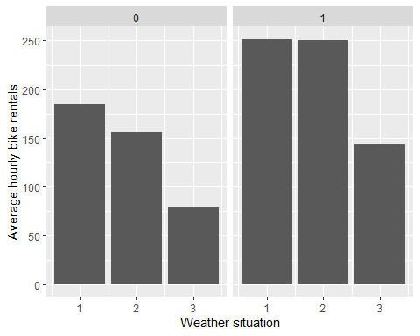

The bar plots show the bike rentals at 9:00 at different weather situations. There are 2 groups, “1” represents working day, “0” otherwise.  
Lesson: Bike rentals are higher on working days. Bike rentals are higher on good-weather days. The difference of bike rentals between weather situation “1” and “2” is smaller on working days than that on non-working days.